| LeafSense |
| --- |
| Application User Manual |
| Model v4.0 |



|  |
| --- |

**Contents**

1. General Information 2

1.1 Introduction 2

1.2 Model 2

1.3 Usages 3

1.4 Classes 3

2. Model Setup 4

2.1 System Requirements 4

2.2 Download & Extract Zip File 4

2.3 Install Necessary Libraries 5

2.4 Boot the Application 6

3. Application Instructions 7

3.1. Navigation 7

3.2. Image Upload 9

3.3. Training & Analysis 11

4. Troubleshooting & Support 12

# General Information

## Introduction

The **Plant Disease Detection Model** is a powerful application designed to identify diseases in plants through image-based analysis. By leveraging advanced machine learning techniques, this model provides farmers, researchers, and agricultural professionals with accurate and efficient diagnostic capabilities, helping to mitigate crop losses and improve yield quality.

Agricultural productivity is often hindered by plant diseases, which are difficult to diagnose manually without expert knowledge. Our **Leaf Sense Model** addresses this challenge by enabling users to upload images of plant leaves and instantly receive a diagnosis, along with information on the disease and recommended remedies.

This document serves as a comprehensive guide for installing, using, and understanding the functionalities of the model. Whether used in academic research, farming, or educational settings, the application ensures ease of use and accessibility, empowering users to make data-driven decisions for plant health management.

## Model

### LeafSense Model: Plant Disease Detection System

The **LeafSense Model** is a deep learning-based system built using the DenseNet121 Convolutional Neural Network (CNN) architecture. It utilizes transfer learning with DenseNet121, fine-tuned specifically for the classification of plant diseases.

The model was trained on a diverse dataset consisting of more than 20,000 labeled images of healthy and diseased plant leaves, achieving an accuracy of over 95%.

Key features of the **LeafSense Model** include:

* **Advanced Architecture**: DenseNet121 enhances feature propagation and mitigates the vanishing gradient problem, resulting in reliable and accurate classifications.
* **Fast and Scalable**: Optimized for deployment on computers ie edge devices, enabling real-time disease detection.
* **Robust Performance**: Techniques such as dropout (0.5) and batch normalization ensure the model remains generalizable and resistant to overfitting.

The **LeafSense Model** is designed to provide a reliable, scalable, and high-performance solution for agricultural disease detection, empowering farmers with fast and actionable insights to protect their crops.

## Usages

The **Plant Disease Detection Model** can be applied in various scenarios to improve agricultural practices and plant health management. Key usages include:

1. **Disease Diagnosis**: Quickly identify plant diseases by uploading images of affected leaves, enabling timely intervention.
2. **Farm Management**: Assist farmers in monitoring crop health and preventing disease spread, reducing crop losses.
3. **Research Support**: Aid researchers in studying disease patterns and evaluating the effectiveness of treatments.
4. **Agricultural Advisory**: Empower agricultural extension officers to provide accurate disease diagnoses and management recommendations.

This tool is designed to simplify disease identification, support decision-making, and enhance overall crop productivity.

## Classes

The **Plant Disease Detection Model** is trained to classify the following plant conditions:

**Healthy Classes (3):**

1. **Pepper Bell**: Healthy
2. **Potato**: Healthy
3. **Tomato**: Healthy

**Unhealthy Classes (12):**

* **Pepper Bell**:
  1. Bacterial Spot
* **Potato**:
  1. Early Blight
  2. Late Blight
* **Tomato**:
  1. Bacterial Spot
  2. Early Blight
  3. Late Blight
  4. Mold
  5. Septoria Leaf Spot
  6. Spider Mites / 2 Spotted Spider Mites
  7. Target Spot
  8. Yellow Leaf Curl Virus
  9. Mosaic Virus

The Plant Disease Detection Model is designed to classify 15 distinct conditions, comprising 3 healthy classes and 12 unhealthy classes across Pepper Bell, Potato, and Tomato plants.

# Model Setup

## 2.1 System Requirements

To run the **Plant Disease Detection Model** efficiently, ensure your system meets the following specifications:

**Hardware Requirements**

* **Processor**: Minimum Intel Core i5 or equivalent (Intel Core i7 or higher recommended)
* **RAM**: At least 8 GB (16 GB recommended for optimal performance)
* **Storage**: Minimum 500mb of available disk space

**Software Requirements**

* **Operating System**: Windows 10/11, macOS 10.15 or later, recent Linux distribution (e.g., Ubuntu 20.04+)
* **Python Version**: Python 3.10.11 (available in Microsoft Store)

**Image Capture Guidelines for Optimal Prediction Accuracy**

* **Ensure a Clear and Uniform Background**To enhance the accuracy of the prediction, capture images against a uniform background with minimal noise and distractions. A plain, high-contrast background improves segmentation and feature extraction, leading to more reliable results.
* **Use a Singular Leaf for Analysis**For higher prediction accuracy, isolate a single leaf in the image. This prevents overlapping foliage or external elements from interfering with the model’s ability to detect and classify diseases accurately.
* **High quality image needed**

## 2.2 Download & Extract Zip File

Click on the zip file to download, once downloaded, extract the zip file.

## 2.3 Install Necessary Libraries

To ensure the **Plant Disease Detection Model** runs smoothly, you need to install the following libraries. Use the commands below to install them via pip in Command Prompt: Press **Win + R,** type **cmd**, and press **Enter,** Alternatively, users can run libraries_install.ipynb for easy installation.

1. **Flask**: For creating a web-based interface.

1. **TensorFlow/Keras**: For loading and running the trained deep learning model.

1. **NumPy**: For handling numerical computations and array operations.

1. **Pillow (PIL)**: For image processing and handling image formats.

1. **OpenCV**: For image loading and processing.

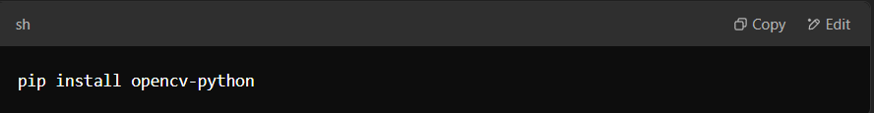

1. **Verify Each Installation**: After running each command, you can verify the library is installed by typing:

For example

## 2.4 Boot the Application

After unzipping the file, locate the file app.py.

Run the app.py file in Command Prompt, Windows PowerShell or a Python terminal.

Use the http address, ctrl + click to navigate to our webpage.



Congratulations! You are on our webpage!

Click on “Get Started” to navigate to the Model page and start diagnosing your plants.

# Application Instructions

## 3.1 Navigation

To navigate between pages, click on the specific pages you want on the side bar.



Home page:

About Us page:

Model page

Customer Review page:

## 

## 3.2 Image Upload

In the Model page, click on “Choose File” and upload the image of your liking.

ie.

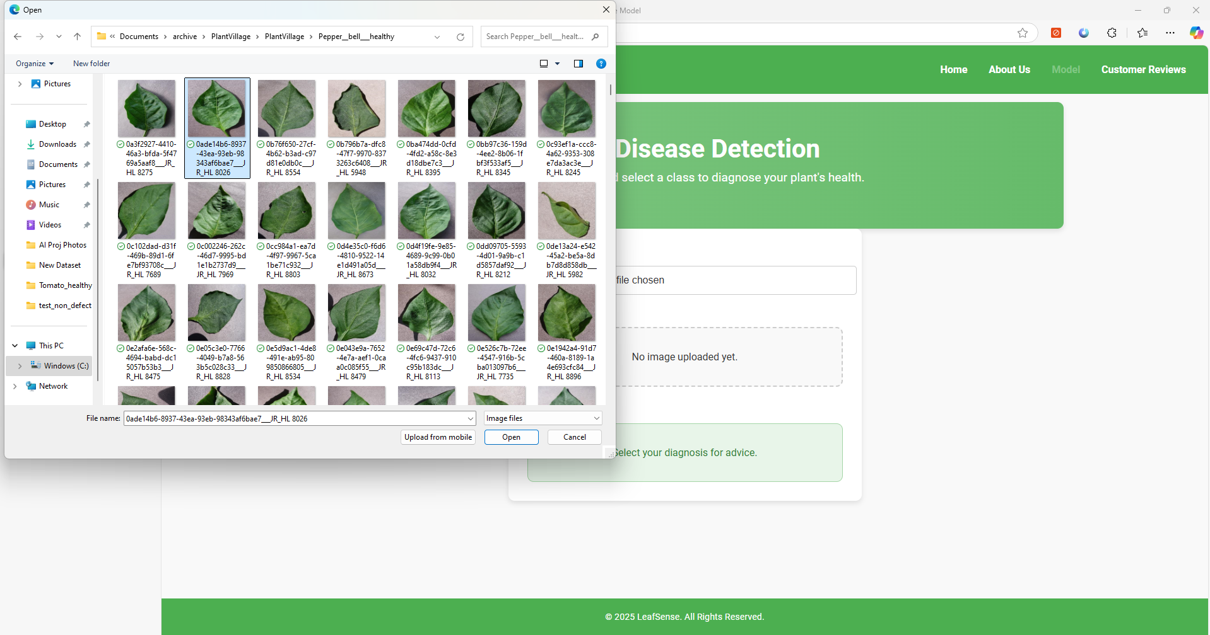

You will see your image being successfully uploaded.

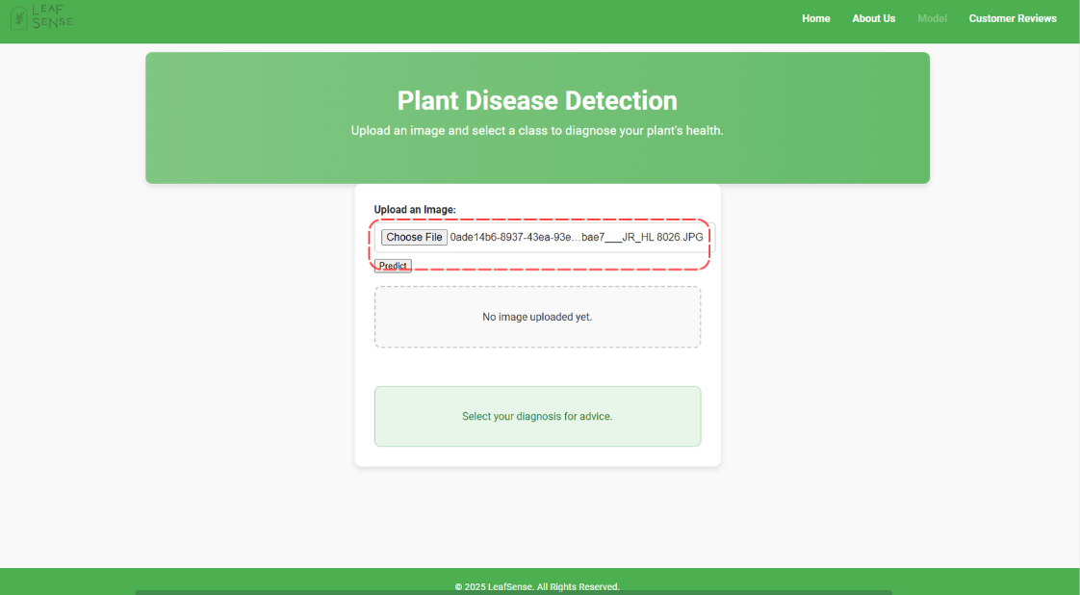

## 

## 3.3 Training & Analysis

Once you upload the image, simply click on predict and wait patiently for the results.

Your diagnosis will appear here. Advice will also be given if your plant is unhealthy.

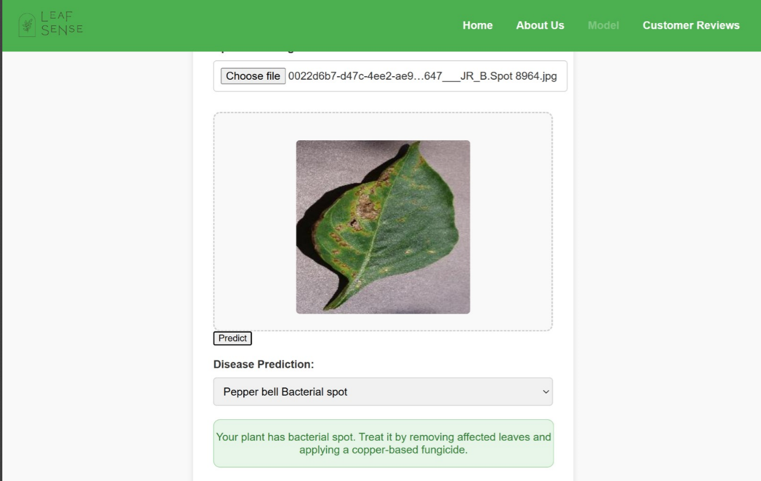

# Troubleshooting & Support

**Common Issues and Solutions**

1. **Application Not Starting**:

* **Cause**: Missing dependencies or incorrect Python version.
* **Solution**: Ensure all required libraries are installed (e.g., Flask, TensorFlow, NumPy, Pillow) and Python 3.8+ is being used. Run:



To reinstall all dependencies.

2. **Model Not Loading**:

* **Cause**: Missing or misplaced model file.
* **Solution**: Verify that the trained model file (.h5 or equivalent) is in the correct directory. Check the file path specified in the code.

3. **Incorrect Predictions**:

* **Cause**: Low-quality input images.
* **Solution**: Ensure uploaded images are clear, well-lit, and focused on the plant leaf. Avoid images with excessive noise or background distractions.

4. **Flask Server Not Running**:

* **Cause**: Port conflict or incorrect command.
* **Solution**: Ensure the specified port (default: 5000) is not in use. Run the application using



5. **Slow Performance**:

* **Cause**: Insufficient system resources.
* **Solution**: Use a machine with higher RAM and a dedicated GPU for faster inference.

**Support Contact**

If the issue persists, contact the development team for assistance:

* **Email**: support@LeafSense.com
* **Phone**: +65 91686799
* **Support Hours**: Monday to Friday, 9:00 AM to 6:00 PM (GMT+8)

For detailed guidance, please consult the user manual or visit our website at [www.LeafSense.com](http://www.leafsense.com).